Smart Food Spoilage Detection and Food Storage System
Akik Salim, Subah Hasan Samanta, Iqramul Hasan Sarkar, Mehidi Hasan Tamim, Wasemun Hasan
0112331157, 0112330899, 0112331080, 0112230067, 0112320241
Department of Computer Science and Engineering
United International University, Dhaka, Bangladesh
Group-2
Abstract: Food spoilage is a major concern in storage systems, supermarkets, and households, leading to health risks and economic loss. This project proposes the design and implementation of a Smart Food Spoilage Detection System that can automatically detect spoiled food using a combination of environmental sensors and image-based machine learning techniques. The system utilizes gas and temperature sensors to monitor storage conditions and detect early signs of spoilage, while a camera-based model identifies spoiled food items individually. By integrating embedded systems with machine learning, the project aims to provide an efficient, low-cost, and practical solution for food quality monitoring. Future improvements may include automated sorting mechanisms and IoT-based remote monitoring.

Project Description:
The “Smart Food Spoilage Detection System” is an intelligent embedded system designed to detect and prevent food spoilage using a combination of sensor-based monitoring and image-based machine learning techniques. The system integrates both hardware and software components to provide a reliable and automated solution for food quality assessment.
Initially, food items are placed inside a storage unit equipped with environmental sensors. Gas sensors detect the presence of gases such as ammonia and methane released during decomposition, while temperature and humidity sensors monitor the storage conditions. These sensor readings are collected by the Arduino Uno and transmitted to the Raspberry Pi 4 for further processing.
A machine learning model analyzes the sensor data to identify early signs of spoilage. If abnormal conditions are detected, the system generates an alert to notify the user. After this initial screening, food items are transferred to a conveyor system where a camera captures images of each item. These images are processed using a trained model (e.g., via Edge Impulse) to classify the food as fresh or spoiled.
Based on the classification result, an automated sorting mechanism using a servo motor separates spoiled items from fresh ones. This dual-stage approach—combining environmental sensing and visual inspection—enhances detection accuracy and ensures efficient operation.
The system aims to provide a cost-effective, scalable, and practical solution for reducing food waste and improving food safety in both domestic and industrial environments.
Project Goals (According to SWOT):
Strengths
- Hybrid Detection Approach:
Combines sensor-based monitoring and image-based classification, improving overall accuracy and reliability.
- Early Spoilage Detection:
Gas and environmental sensors enable detection before visible spoilage occurs.
- Automation Capability:
Conveyor system and servo-based sorting reduce manual effort and increase efficiency.
- Real-Time Processing:
Continuous monitoring and instant decision-making improve responsiveness.
- Low-Cost Implementation:
Uses affordable components such as Arduino Uno and Raspberry Pi 4, making it suitable for student and small-scale applications.
Weaknesses
- Sensor Accuracy Limitations:
Gas sensors may be affected by environmental noise, leading to possible false readings.
- Limited Dataset for Training:
Image-based model accuracy depends on the quality and size of the dataset.
- Processing Delay:
Image processing may introduce slight delays in real-time systems.
- Hardware Dependency:
System performance relies heavily on proper calibration and hardware stability.
Opportunities
- Industrial Application:
Can be expanded for use in food warehouses, supermarkets, and cold storage facilities.
- IoT Integration:
System can be connected to cloud platforms for remote monitoring and alerts.
- Model Improvement:
Accuracy can be increased over time by training with larger datasets.
- Multi-Food Classification:
Can be extended to classify different types of food and their spoilage levels.
Threats
- Environmental Variability:
Changes in temperature, humidity, or external gases may affect sensor performance.
- Lighting Conditions:
Poor lighting can impact image classification accuracy.
- Hardware Failure:
Failure of sensors, camera, or motors can disrupt system operation.
- Competition with Advanced Systems:
More advanced industrial solutions may offer higher precision and robustness.

Project Overview: This project presents a hybrid system that combines sensor-based monitoring and image-based detection to identify spoiled food items. Initially, food items are stored inside a container equipped with gas and temperature sensors. These sensors continuously monitor environmental changes caused by food decomposition. A machine learning model processes this data to determine whether spoilage risk exists. If abnormal conditions are detected, the system alerts the user. After manual inspection, food items are passed through a conveyor system where each item is analyzed individually using a camera. The image data is processed using a trained model to classify each item as fresh or spoiled. This two-stage detection system ensures both early warning and precise identification. The system integrates hardware components such as a microcontroller (Arduino), a single-board computer (Raspberry Pi), sensors, and actuators to create a complete smart monitoring solution.
Component List:
- Arduino Uno
- Raspberry Pi 4
- MQ-135 Gas Sensor
- DHT11 Temperature sensor
- Camera Module (Raspberry Pi Camera)
- Conveyer Motor + Motor Driver
- Buzzer/ LED
- Servo Motor

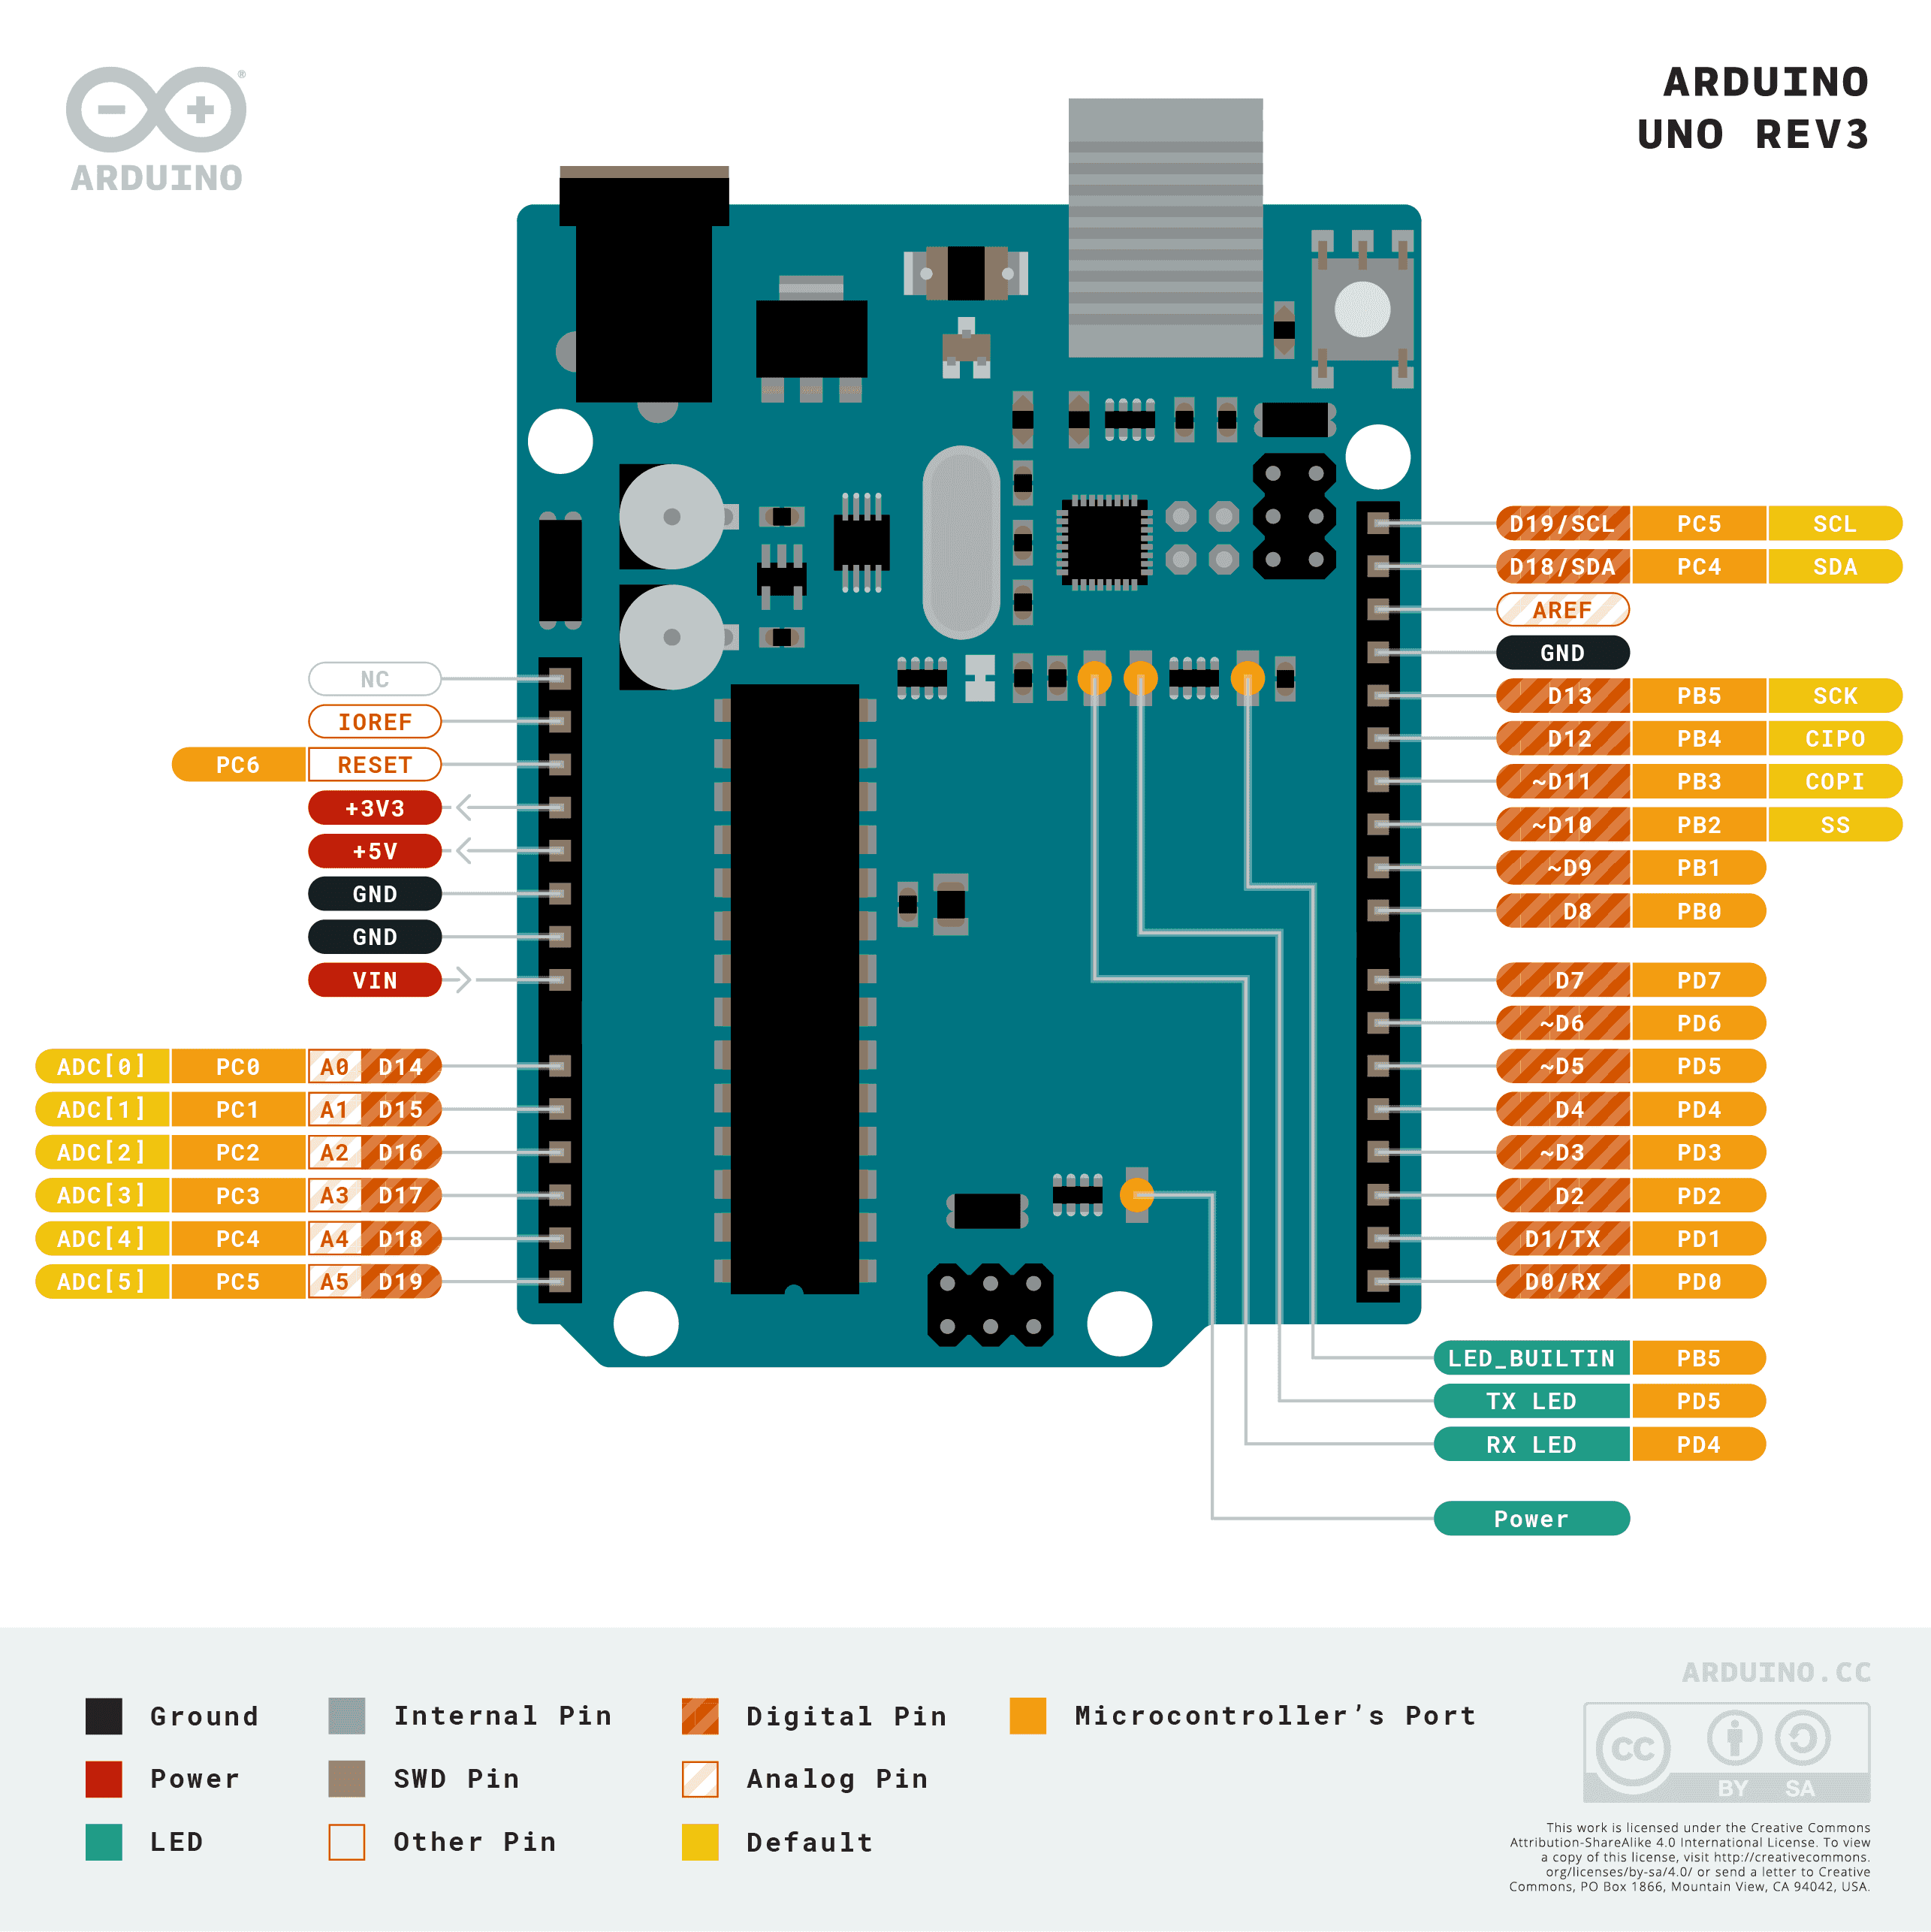
1. Arduino Uno
Purpose
The Arduino Uno serves as the central data acquisition and control unit of the system. It is responsible for collecting real-time data from various sensors such as the gas sensor and temperature sensor, processing basic control logic, and managing output devices including buzzers, LEDs, and motors. It also plays a crucial role in transmitting sensor data to the Raspberry Pi for further analysis and machine learning processing.
Overview
The Arduino Uno is an open-source microcontroller board based on the ATmega328P microchip. It is widely used in embedded systems due to its ease of programming, flexibility, and reliability. The board can read both analog and digital inputs, process them in real time, and generate appropriate outputs, making it highly suitable for sensor-based automation systems.
Features
- Microcontroller (ATmega328P):
Acts as the core processing unit that executes programmed instructions, processes sensor inputs, and controls output devices efficiently in real time.
- Analog Input Pins (A0–A5):
These pins are used to read analog signals from sensors such as gas sensors. The built-in ADC converts these signals into digital values (0–1023), enabling accurate measurement and analysis.
- Digital I/O Pins:
Used to interface with components like the DHT11 sensor, buzzer, LEDs, and motor drivers. These pins operate using HIGH/LOW logic signals for effective control.
- Serial Communication (UART):
Enables real-time communication with the Raspberry Pi via USB, allowing continuous data transfer for logging and machine learning processing.
- Operating Voltage (5V):
Ensures compatibility with most sensors and modules, providing stable and reliable system operation.
- Memory System:
Includes 32KB Flash memory for program storage, 2KB SRAM for temporary data handling, and 1KB EEPROM for storing small persistent data.
- USB Interface:
Allows easy program uploading and real-time debugging using tools such as the Serial Monitor.

2. Raspberry Pi 4
Purpose
The Raspberry Pi 4 functions as the main processing and decision-making unit of the system. It is responsible for performing advanced tasks such as machine learning inference, image processing, and data storage. It receives sensor data from the Arduino and combines it with image-based analysis to determine whether food items are fresh or spoiled.
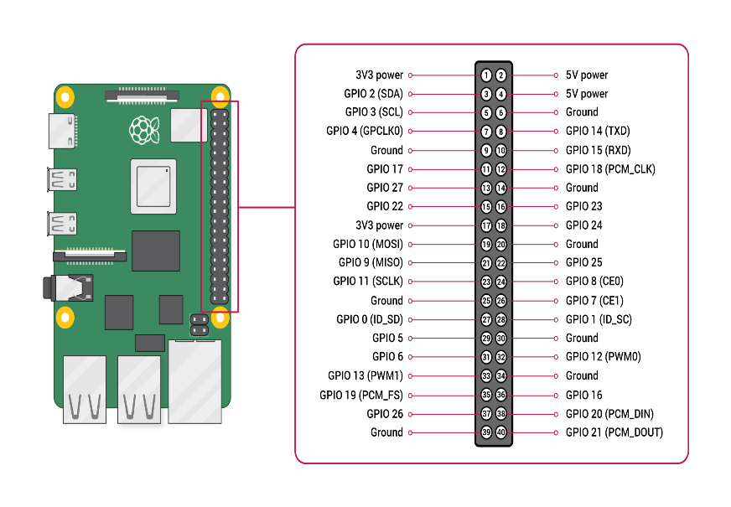
Overview
The Raspberry Pi 4 is a high-performance single-board computer capable of running a full Linux operating system. It provides sufficient computational power to handle complex operations such as running machine learning models and processing real-time image data, making it ideal for intelligent embedded systems.
Features
- Powerful Processor:
Equipped with a quad-core CPU capable of handling computationally intensive tasks such as image classification and ML model execution.
- RAM Capacity:
Available in multiple configurations (2GB, 4GB, 8GB), allowing efficient multitasking and handling of large datasets.
- USB Communication:
Enables reliable data exchange with the Arduino, ensuring continuous real-time sensor data processing.
- Camera Interface (CSI):
Provides a dedicated high-speed interface for camera modules, enabling low-latency image capture and processing.
- Storage (MicroSD Card):
Used for storing the operating system, datasets, and trained machine learning models.
- Wireless Connectivity:
Built-in Wi-Fi and Bluetooth support future extensions such as IoT-based monitoring and cloud integration.
- Software Support:
Supports programming environments like Python and integrates with tools such as Scikit-learn and Edge Impulse.

3. Gas Sensor (MQ-135)
Purpose
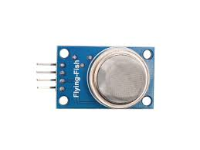
The gas sensor is used to detect gases released during food decomposition, such as ammonia, methane, and carbon dioxide. It plays a critical role in identifying early signs of food spoilage within the storage environment.

Overview
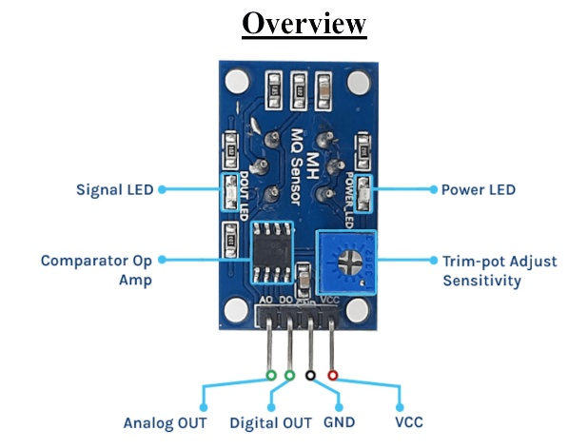
MQ-series gas sensors operate by detecting changes in resistance when exposed to different gases. These changes are converted into analog voltage signals, which are read by the Arduino and used to determine gas concentration levels.
Features
- Analog Output (0–1023):
Provides a continuous signal corresponding to gas concentration, enabling precise monitoring.
- High Sensitivity:
Capable of detecting even small amounts of gas, allowing early spoilage detection.
- Multi-Gas Detection:
Detects gases such as ammonia (NH₃), methane (CH₄), and carbon dioxide (CO₂), commonly associated with food spoilage.
- Adjustable Sensitivity:
Includes a potentiometer for calibration, allowing adaptation to different environments.
- Fast Response Time:
Quickly reacts to changes in gas levels, enabling real-time monitoring.
- Operating Voltage (5V):
Compatible with Arduino for easy integration.

4. Temperature Sensor (DHT11)
Purpose
The DHT11 sensor is used to monitor temperature and humidity inside the storage environment, as both factors significantly influence the rate of food spoilage.
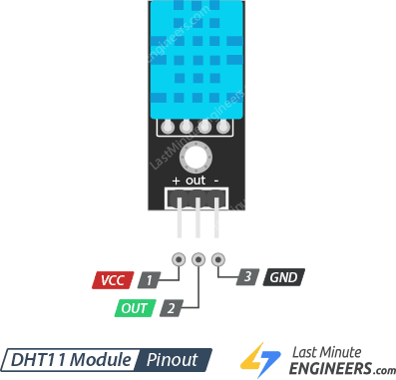
Overview
The DHT11 is a digital sensor that provides calibrated temperature and humidity readings. It communicates directly with the microcontroller using a single-wire protocol, making it simple and efficient to use in embedded systems.
Features
- Digital Output:
Provides direct digital readings, reducing noise and improving reliability.
- Temperature Measurement:
Measures temperature within a range suitable for food storage monitoring.
- Humidity Measurement:
Measures relative humidity, which affects microbial growth and spoilage rate.
- Low Power Consumption:
Suitable for continuous monitoring applications.
- Simple Interface:
Uses a single-wire communication protocol for easy integration.
- Cost-effective:
Affordable and reliable for student-level projects.

5. Camera Module
Purpose
The camera module is responsible for capturing images of food items for visual inspection and classification into fresh or spoiled categories.
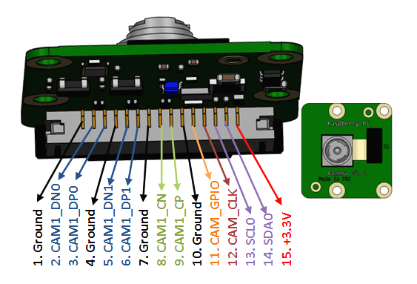
Overview
The camera is connected to the Raspberry Pi and captures images as food items pass through the conveyor system. These images are processed using a trained machine learning model to determine food quality.
Features
- High-Resolution Image Capture:
The camera captures clear and detailed images, which helps the system identify visual features such as color changes, texture, and spoilage signs. Higher image quality improves the accuracy of the machine learning model.
- Real-time Processing:
It supports continuous image capture as food items move along the conveyor. This allows the system to analyze each item instantly without stopping the process, improving efficiency.
- Machine Learning Integration:
The camera works with platforms like Edge Impulse, enabling easy training and deployment of image classification models. Captured images are directly used for prediction.
- Compact Design:
Its small size makes it easy to install in the system, especially above the conveyor, without requiring complex setup.
- Stable Image Capture: The camera can be positioned to capture images at the right moment, reducing motion blur and ensuring consistent image quality for better classification.

6. Gear Motor
Purpose
The purpose of using a gear motor in a project is to achieve precise, stable, and high-torque mechanical motion. It allows the system to move heavier loads smoothly at controlled speeds, which cannot be efficiently handled by a normal DC motor. In conveyor-based or robotic systems, it ensures reliable performance under continuous operation.
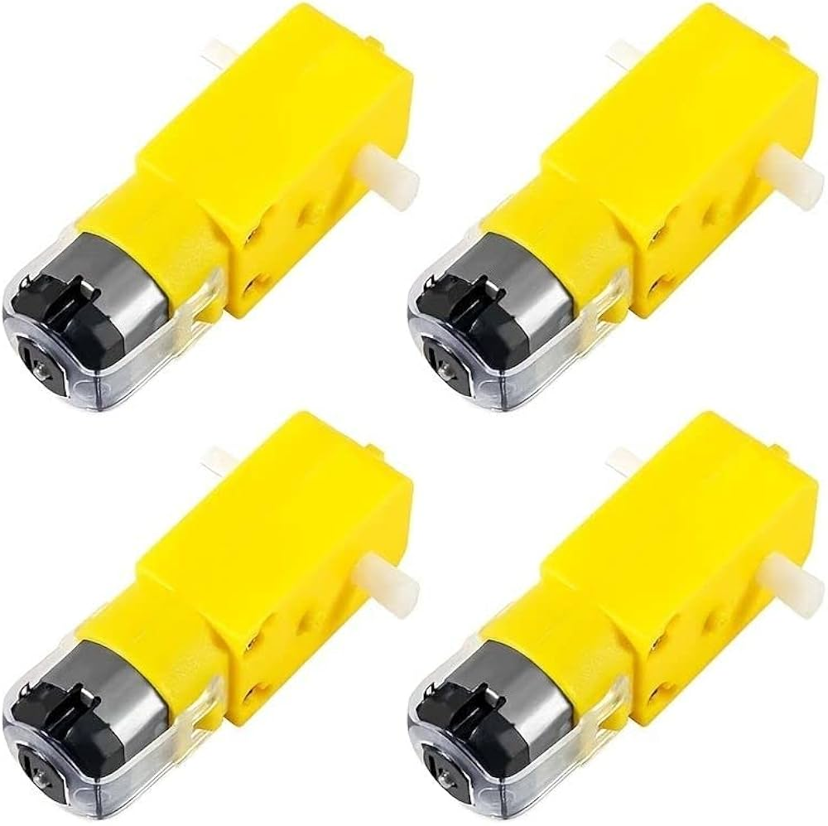
Overview
A gear motor is an electromechanical device that combines a DC motor with a gear reduction system. The gearbox reduces the high rotational speed of the motor and converts it into a lower speed with higher torque output. This makes it highly suitable for applications that require controlled motion and strong mechanical force. Gear motors are commonly used in automation systems, robotics, conveyor belts, and industrial prototype projects.
Features
- High Torque Output: Provides strong rotational force, making it suitable for lifting or moving heavy loads.
- Speed Reduction Mechanism: Internal gears reduce RPM while increasing torque for controlled motion.
- Better Load Handling: Can operate efficiently under mechanical stress without stalling easily.
- Stable and Smooth Operation: Ensures consistent rotation with minimal vibration.
- Wide Range of RPM Options: Available in different speed ratings (e.g., 5 RPM to 300 RPM or more) depending on application needs.
- Energy Efficient Output: Converts motor power into usable mechanical force effectively through gear reduction.
- Directional Control Support: Can rotate clockwise or counterclockwise when connected with motor drivers.
- Compact Design: Combines motor and gearbox in a single unit, saving space in embedded systems.
- Compatible with Microcontrollers: Easily controlled using Arduino, Raspberry Pi, or motor driver circuits (L298N, L293D, etc.).
- Continuous Operation Capability: Designed to run for long durations in automation and prototype systems.

7. Motor Driver Module (L298N)
Purpose
The motor driver module enables the microcontroller to control the DC motor by supplying the required current and voltage, which cannot be provided directly by the Arduino.
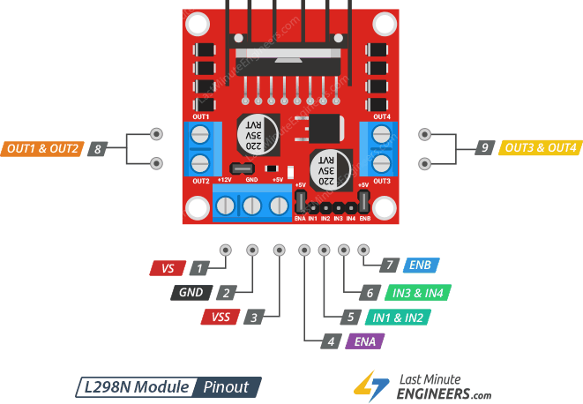
Overview
The motor driver acts as an interface between the Arduino and the motor, allowing control over motor speed and direction while protecting the microcontroller from high current.
Features
- High Current Handling:
Supports motors requiring higher current.
- Bidirectional Control:
Allows forward and reverse motion.
- PWM Speed Control:
Enables precise speed adjustment.
- Thermal Protection:
Prevents overheating and damage.
- Multi-Motor Support:
Can control multiple motors if needed.

Project Timeline:
Week | Planned Task
Week 1-2 | Research, component selection and proposal writing
Week 3-4 | Component procurement and initial circuit testing
Week 5-6 | Software development and sensor integration
Week 7-8 | Final assembly, troubleshooting, and report drafting

Features:
- Food Storage Unit
- Data Collecting
- Machine Learning Processing
- Camera Module
- Conveyer System and food sorting

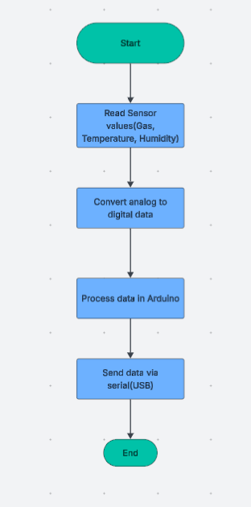
- Food Storage Unit:
This is the initial stage where food items are stored in a container equipped with sensors. Gas and temperature sensors continuously monitor environmental conditions to detect early signs of spoilage.

2. Data Collecting
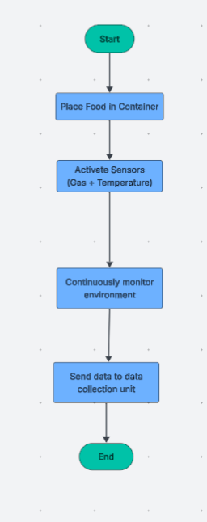
Sensor data is collected using the Arduino Uno. It reads real-time values (gas, temperature, humidity) and sends them to the processing unit for further analysis.

3. Machine Learning Processing
The Raspberry Pi 4 processes the collected data using machine learning models. It analyzes both sensor data and image data to predict whether the food is fresh or spoiled.

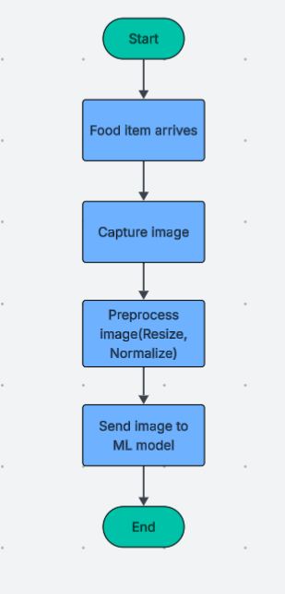
4. Camera Module
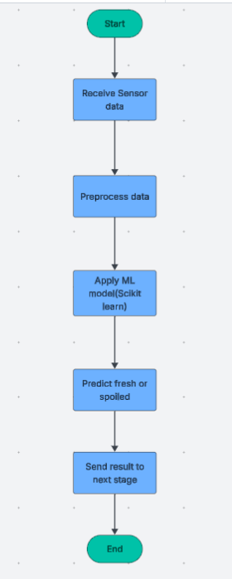
The camera captures images of food items as they pass through the system. These images are used by the machine learning model to perform visual classification.

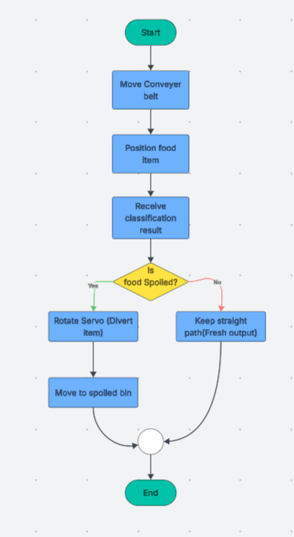
5. Conveyor System and Food Sorting
The conveyor moves food items for inspection. Based on the classification result, a servo motor automatically sorts spoiled items into a separate bin, while fresh items continue forward.

Benchmark Analysis:
  - Machine Learning & Accuracy Benchmarks
The sources provide several benchmarks for the accuracy of AI models used in food classification and spoilage detection:
- Overall CNN Accuracy: A Convolutional Neural Network (CNN) model designed to detect fruits and veggies achieved an accuracy rate of 95%.
- Industry Comparison: Similar e-nose systems cited in the sources reached 92% accuracy for banana and leeks, and 91% accuracy for durian ripeness.
- Training Requirements: For efficient fruit recognition, a model should be trained with more than 20 images for each type of fruit.
- Model Complexity: A high-performing model described in the papers utilized 11 layers, including four convolutional and four max-pooling layers.
- Biological and Chemical Benchmarks
To validate your sensors against traditional laboratory methods, you can use these biological standards:
- Microbial Population: Beef is considered spoiled when the aerobic bacteria population exceeds log CFU/g.
- pH Levels: Fresh beef typically starts with a pH of approximately 5.4; as it spoils over 7 days, this level can rise to above 8.2.
- Shelf Life Extension: A successful smart management system was able to increase the shelf life of certain food categories by 2 days.
- Hardware Operational Benchmarks
These technical specifications define the operational limits of the components in your project:
- Data Resolution: The Arduino Uno's built-in ADC converts analog sensor signals into a digital range of 0–1023.
- Mechanical Throughput: Gear motors for the conveyor system should be capable of speeds between 5 RPM and 300 RPM to handle different loads.
- Temperature Sensitivity: Sensors like the AM2302 (DHT22) provide accuracy within °C.
- Identified System Weaknesses (Performance Targets)
The papers also list "benchmarks of failure" or weaknesses that your project should aim to minimize:
- Processing Latency: Image processing on a Raspberry Pi 4 can introduce slight delays, which is a key performance area for optimization.
- Environmental Noise: Gas sensors like the MQ-135 are noted for being affected by external gases, humidity, and temperature changes, requiring careful calibration.

- Shelf Life Extension: 2-Day Increase
The experimental results demonstrate that by using a smart monitoring system to maintain the environment (temperature and humidity) according to the specific needs of the food item, the shelf life of various food categories was successfully increased by 2 days.
Specific examples of this benchmark from the study's experimental analysis include:
- Broccoli: Extended from a maximum approximate storage life of 14 days to 16 days.
- Eggplant: Extended from 7 days to 9 days.
- Cabbage (Early): Extended from 42 days to 44 days.
- Cauliflower: Extended from 120 days to 122 days.
This benchmark serves as a direct measure of the system's practical effectiveness in reducing food waste, moving beyond mere detection to active preservation

References:
  - https://ieeexplore.ieee.org/document/8888049
  - https://www.frontiersin.org/journals/public-health/articles/10.3389/fpubh.2021.816226/full
  - https://www.researchgate.net/profile/Harshwardhan-Pandit/publication/379830386_Use_of_Machine_Learning_and_Artificial_Intelligence_in_Food_Spoilage_Detection/links/661d5a2043f8df018d0e42fa/Use-of-Machine-Learning-and-Artificial-Intelligence-in-Food-Spoilage-Detection.pdf
  - https://www.mdpi.com/2079-4983/12/4/67
  - https://pubs.rsc.org/en/content/articlehtml/2024/fb/d4fb00072b

